Using a qualitative model to explore the relative impacts of ecosystem drivers in declining marine survival in Pacific Salmon

K. Sobocinski, C. Greene, M. Schmidt

v.1

May 16, 2016

# Introduction

Problems of complex interactions are common in many fields, including medicine, economics, and ecology (Levins 1974). In ecology, much attention has been given to describing foodwebs and interactions among species (May 1974, Paine 1966, Pimm et al. 1991, Dunne et al. 2002). But often, these foodwebs are nested within larger ecological or social-ecological contexts where exogenous forces may influence components of the foodweb system. External forcings may include physical drivers, anthropogenic impacts, or ecosystem components that are not characterized within the focal network. In social-environmental systems, tools that incorporate abiotic variables and management actions within the same analytical framework are needed to accurately understand the dynamics of complex systems. While complicated end-to-end models such as *Atlantis* are coming to the forefront in marine ecosystem management (Ainsworth et al, 2010, Fulton et al. 2011) these models are complex, data-intensive, and require high levels of expertise to develop and run. Here we use a qualitative network model (QNM, or loop analysis), a conceptually-based, data-free modeling approach, to address impacts to early marine survival of juvenile salmon, given diverse and complex interactions in the Salish Sea.

In recent years, attention has turned to early marine life-history stages of Pacific Salmon in an effort to understand population declines and failure to rebound given myriad conservation and restoration efforts in freshwater streams. In Chinook, Coho, and Steelhead salmon (*Oncoryhchus tshawytscha*, *O. kisutch*, and *O. mykiss*, respectively), declines in survival have been evidenced within Puget Sound, WA, USA and the Strait of Georgia, Canada that have not been seen in coastal populations (Ruff et al. XXXX, Zimmerman et al. 2015, Kendall et al. XXXX, Johannessen and McCarter 2010). These water bodies, collectively the Salish Sea, serve as habitats for juvenile salmon as they pass from natal streams to ocean waters during their outmigration period. Yet, because of complex anthropogenic changes brought about by climate change, population increases, land use change, and human activity in these coastal waters, it is likely that a number of factors and their cumulative—synergistic or additive—effects are contributing to increasing marine mortality. Other salmon species, such as Chum, Pink and Sockeye salmon (*O. keta*, *O. gorbuscha*, and *O. nerka*, respectively), have not experienced similar declines, suggesting that life history characteristics may contribute to increased mortality in this region. Teasing apart which of these factors have negatively impacted survival of juvenile salmon in marine water waters is of concern to local, regional, and federal governments and other stakeholders (e.g. Salish Sea Marine Survival Project, <http://marinesurvivalproject.com/>) so that management actions can be taken to lessen impacts and increase survival during this period.

While correlative studies of salmon abundance and environmental factors have been on-going in the greater region for many years (Pearcy 1988, Beamish et al. 2000, Teo et al. 2009), new focus is being paid specifically to early marine stages and impacts including oceanographic and environmental conditions, anthropogenic impacts, and foodweb components within the Salish Sea. In addition to focus on oceanographic conditions and salmon, foodweb models have been developed for the Strait of Georgia (Priekshot 2008) and Puget Sound (Harvey et al. 2012). These models show…. But even with an understanding of the main interactors, or variables, in a given system, measuring abundances of each variable and the flux of material/energy/data etc. among them often poses a logistical challenge (Christensen and Walters 2004). It is the rare system that is ever completely specified (Levins 1974). For this reason, conceptually-based models, incorporating a broader array of variables, are an important tool in modeling and can provide a holistic picture of ecological and human drivers of ecosystem change.

One tool for evaluating the relative influence of ecosystem components is a Qualitative Network Model (QNM also called Loop Analysis, Levins 1974, Raymond et al. 2011, Melbourne-Thomas et al. 2012). This approach is advantageous for understanding a system of complex interactions which may not be fully specified and when precise measurement is impossible, but when a mechanistic understanding of interactions exists. It also allows the testing of competing hypotheses, given different model structure or the invocation of perturbations to one or more of the model variables. QNM does not explicitly include magnitudes or non-linear direct effects, both of which occur in and influence social and ecological systems. However, a QNM may help to determine what should be measured to improve system understanding (Levins 1974), targeting additional research efforts.

Researchers have used QNM for evaluating ecosystem response to ocean acidification in shellfish management (Reum et al. 2015), the impacts of eutrophication and species management within a foodweb (Carey et al 2013), and for discerning the impact of management actions for species recovery (Harvey et al. 2016) in the Pacific Northwest. Qualitative Network Analysis (QNA) is an important conceptual tool for discerning relative impacts of ecosystem components. Here we apply this technique to evaluate a suite of potential drivers thought to be contributing to increased early marine mortality in a suite of Pacific Salmon.

# Methods

We used a QNM to address our main question of the relative impacts of various factors on salmon early marine survival. Our analysis had three main steps: 1.) Construct an enhanced conceptual model showing positive, negative, and neutral relationships using a digraph; 2.) Generate a pool of simulated models, with random weights applied to each model linkage; and 3.) Invoke one or more perturbations based upon mechanistic understanding of the system and determine the model response. We describe these steps in detail below.

## Conceptual Model

To construct our conceptual model of the Salish Sea system, we gathered experts and literature on ecosystem components and iteratively developed a working model. We began by developing a Kaje matrix (Kaje 1999) listing over 40 possible drivers and the relationships among them. These drivers were drawn from hypotheses about the decline of Pacific salmon within the system (Salish Sea Marine Survival Project hypotheses, <http://marinesurvivalproject.com/wp-content/uploads/Comprehensive-list-of-hypotheses1.pdf>). Relationships among drivers were either positive, negative, uncertain, or null and were based upon mechanistic understanding of physical forcing, the foodweb, and drivers of salmon production within the Salish Sea, as well as human impacts. From the Kaje matrix, we developed a digraph using the directed graphing software, Dia (v.0.97.2). This digraph served as the foundation for our qualitative modeling.

While the emphasis of the modeling effort was on understanding mortality of the focal salmon species (Chinook, Coho, and Steelhead), we included salmon life history traits within the conceptual model to specifically evaluate impacts to traits such as size, fitness, residence time, abundance and survival—these served as response variables within our perturbation scenarios. The inclusion of model compartments that are not biomass pools highlights the flexibility of qualitative models. While the emphasis was in representing the most direct impacts to the focal salmon traits, we recognize that many of the model components (e.g. temperature) could potentially have direct connections to other model components; we have included these where interactions were important for understanding implications for salmon.

## Simulated Networks

We used the *QPress* package for Qualitative Network Analysis (Raymond et al. XXXX) in R (R Core Team 2016) to interpret the conceptual digraph and construct simulated networks. Given a network model, this package provides routines for evaluating the impact of a press perturbation to the system through simulation. We simulated the network ~120,000 times to result in 10,000 stable simulated networks. For each simulation a weight (drawn from a random uniform distribution, 0-1) was assigned to each pathway (edge) and if the resulting model with the assigned weights was stable, the model was accepted.

To assess the sensitivity of the model links in the *QPress* simulations, we calculated means and standard deviations of the weights for all links from the pool of accepted models. Our hypothesis was that some linkages would be more influential in model stability and that those with mean weights different than the expected mean (0.5, given assignments that were random *(U(0,1))*) would provide some indication of sensitivity. In preliminary analysis, we experimented with changing both distribution and the variance of the weighting scheme, but did not find large differences in results, so maintained the default weighting for our analyses.

## Invoking Perturbations

To test a suite of hypotheses concerning drivers to the Salish Sea ecosystem, we developed *a priori* perturbations to invoke upon each model node (Table 1). The direction of the perturbation (increase or decrease) was based upon our understanding of the system, changes that have occurred concomitant with declines in salmon marine survival (beginning in the 1970s), and expected impacts as a result of climate change and the related oceanographic changes. We employed several scenarios within the perturbation routine. First, we perturbed each node individually and observed outcomes to all other model compartments. This allowed for a simple comparison of impacts from each node and the ability to compare the extent of the impact to any model group. Second, we developed scenarios based upon observed changes within three regions of Puget Sound to see how well the model was able to replicate cumulative impacts in terms of response to the focal salmon metrics, especially survival. Third, we evaluated the relative effects of different groups of drivers (Table X). For example, we were interested in foodweb effects, so we decreased the forage fish compartment, increased marine mammals, decreased primary production (diatoms) and increased gelatinous zooplankton and observed the impacts to the other model components. For each driver group, we selected four nodes to perturb, standardizing the level of change. By comparing impacts to salmon traits from foodweb, oceanographic, and anthropogenic drivers, we were able to query the relative impacts of each of these groups to the other model nodes, specifically the salmon traits. In reality, we understand that causes of declining survival are likely multi-faceted, complex, and non-linear, this modeling exercise allowed us to “push some buttons” to examine the relative influence of many factors within one modeling framework.

# Results

Our final conceptual model had 33 nodes including salmon traits and climate/atmospheric, oceanographic, foodweb, and anthropogenic drivers (Fig. 1, Table 1, variables and salmon traits). There were a total of 148 linkages out of 1089 potential linkages within the model. This gives a network density or connectance (realized linkages/potential linkages) of 0.136 and a linkage density (average # of linkages/node) of 4.48. Each model node, with the exception of survival which was considered the primary variable of interest, included a self-limiting loop to aid in model convergence.

The results of the press perturbation to each node showed that anthropogenic impacts had the strongest negative responses in salmon traits, specifically to survival and abundance (Table 1). Only an increase in sunlight and CO2 resulted in strong positive responses in survival and abundance. Since these drivers positively influence diatoms, increases may trigger increased primary production, cascading through the foodweb. Similarly, a decrease in diatoms (primary production) resulted in a strong negative response in survival and abundance. A decrease in zooplankton resulted in strong negative responses in fitness and size, but neutral results in survival and abundance. Conversely, a decrease in turbidity resulted in a strong positive response in fitness and size, but slightly negative responses in survival and abundance, perhaps because of predation dynamics in the model. Unexpectedly, increased harvest had a positive effect on survival; harvest has a direct negative effect on abundance within the model. The feedback to survival is mediated by the foodweb, specifically forage fish and zooplankton.

For the regional differences, we modeled three regions of Puget Sound with different impacts and salmon population trends (Figure 2). The three regions were: a.) South Sound, with a known decline in salmon abundance and cumulative impacts including increased gelatinous zooplankton, nutrients, contaminants and hatchery production and decreased forage fish abundance, b.) Hood Canal, which has had relatively stable salmon abundances, but impacts in oceanography including increased stratification and turbidity and low dissolved oxygen, and c.) Central Basin which has shown a decline in salmon abundance, relatively less than South Sound, but with a different suite of cumulative impacts including habitat loss and decreased primary production. In general, our model replicated the actual trends in salmon within these regions, with strong negative responses in salmon survival, abundance, and fitness in both South Sound and Central Basin (Table 2.). Responses on other salmon (non-focal species, including chum, pinks, and sockeye) were positive in these regions, which has also been observed (Fig. 2).

The results of the driver group analysis, which showed cumulative impacts within one functional section of the network, showed anthropogenic impacts to have the strongest negative effects on survival, abundance, and fitness, with over 80% of the simulations showing negative responses within these model groups. Survival, abundance, and fitness were least impacted by the oceanography driver group perturbation, with the foodweb driver group falling intermediate to the others. The other salmon category showed the most positive response in the foodweb sub-model, indicating that conditions that are less favorable within the foodweb for the focal salmon species may be less detrimental for other species (with diets that tend to be more planktivorous). Zooplankton, which were not manipulated directly, also showed neutral response in the foodweb sub-model, but largely negative responses in the oceanographic and anthropogenic sub-models.

# Discussion

As with any model, ours is a reductionist view of the ecosystem and omission of some connections and ecosystem components was necessary to emerge with a conceptual diagram that was both representative and practical.

# Literature Cited

Ainsworth, C.H. I.C. Kaplan, P.S. Levin, R. Cudney-Bueno, E.A. Fulton, M. Mangel, P. Turk-Boyer, J. Torre, A. Pares-Sierra and H. Morzaria Luna. 2010. Atlantis model development for the Northern Gulf of California. *NOAA Technical Memorandum* NMFS-NWFSC-110, 313 p.

Beamish, R. J., D. J. Noakes, G. A. McFarlane, W. Pinnix, R. Sweeting, and J. King. 2000. Trends in coho marine survival in relation to the regime concept. *Fisheries Oceanography* 9:114–119.

Carey, M.P., P.S. Levin, H. Townsend, T.J. Minello, G.R. Sutton, T.B. Francis, C.J. Harvey, J.E. Toft, K.K. Arkema, J.L. Burke, C. Kim, A.D. Guerry, M. Plummer, G. Spiridonov, and M. Ruckelshaus. 2014. Characterizing coastal foodwebs with qualitative links to bridge the gap between the theory and the practice of ecosystem-based management. *ICES J Mar Sci* 71: 713−724.

Christensen, V. and C.J. Walters. 2004. Ecopath with Ecosim: methods, capabilities and limitations. *Ecological Modelling* 172:109-139.

Dunne, J. A., R.J. Williams, and N.D. Martinez. 2002. Network structure and biodiversity loss in food webs: robustness increases with connectance. *Ecol. Lett.* 5, 558–567.

Fulton, E.A., Link, J.S., Kaplan, I.C., Savina-Rolland, M., Johnson, P., Ainsworth, C.H., et al. 2011. Lessons in modelling and management of marine ecosystems: The Atlantis experience. *Fish Fisheries*, 12:171–188.

Harvey, C.J., Williams, G.D. & Levin, P.S. Estuaries and Coasts (2012) 35: 821. doi:10.1007/s12237-012-9483-1

Kaje, J. 1999. Kaje System: A conceptual modeling tool for interdisciplinary research. Univ. of Washington Applied Physics Lab.

Levins, R. 1974. The qualitative analysis of partially specified systems*. Annals of the New York Academy of Sciences* 231: 123−138.

May, R. M. 1974. Stability and Complexity in Model Ecosystems. *Monographs in Population Biology* 6 Princeton University Press, Princeton, New Jersey

Melbourne-Thomas, J., S. Wotherspoon, B. Raymond, and A. Constable. 2012. Comprehensive evaluation of model uncertainty in qualitative network analyses. *Ecological Monographs*, 82(4): 505–519.

Paine, R.T. 1966. Food web complexity and species diversity. *American Naturalist* 100: 65-76.

Pearcy, W. G. 1988. Factors affecting survival of Coho Salmon off Oregon and Washington. Pages 67–73 in W. J. McNeil, editor. *Salmon production, management, and allocation*. Oregon State University Press, Corvallis.

Pimm, S. L., Lawton, J. H. & Cohen, J. E. 1991. Food web patterns and their consequences. *Nature* 350, 669–674.

Preikshot, D.B. 2008. *Public Summary—Computer Modelling of Marine Ecosystems: Applications to Pacific Salmon Management and Research*. Vancouver, BC: Pacific Fisheries Resource Conservation Council.

R Core Team. 2016. R: A language and environment for statistical computing. R Foundation for Statistical Computing, Vienna. www.r-project.org

Raymond, B., J. McInnes, J.M. Dambacher, S. Way, and D.M. Bergstrom. 2011 Qualitative modelling of invasive species eradication on subantarctic Macquarie Island. *Journal of Applied Ecology* 48: 181–191.

Raymond, B, J. Melbourne-Thomas, S. Wotherspoon. 2012. QPress: Qualitative Network Analysis.

Reum, J.C.P., B.E. Ferriss, P.S McDonald, D.M. Farrell, C.J. Harvey, T. Klinger, and P.S. Levin. 2015. Evaluating community impacts of ocean acidification using qualitative network models. *Marine Ecology Progress Series* 536: 11-24.

Teo, S. L. H., L. W. Botsford, and A. Hastings. 2009. Spatio-temporal covariability in Coho Salmon (Oncorhynchus kisutch) survival, from California to southwest Alaska. Deep Sea Research Part II: Topical Studies in Oceanography 56:2570–2578.

Table 1. Model nodes (variables) in the Salish Sea QNM, the direction of the press perturbation invoked in the modeling simulation, and the response of the focal salmon traits (Survival, Abundance, Fitness, Size, Residence) and the Other Salmon model group. Key to direction and strength of responses of model simulations is below.

|  |  |  |  |  |  |  |  |  |  |  |
| --- | --- | --- | --- | --- | --- | --- | --- | --- | --- | --- |
| **Drivers** | **Variables** | | **Invoked Perturb.** | **Survival** | **Abund.** | **Fitness** | **Size** | **Resid.** | **Other Salmon** | |
| *Environmental* | Sunlight | | ↑ |  |  |  |  |  |  | |
|  | Winter Storms | | ↑ |  |  |  |  |  |  | |
|  | Precipitation | | ↑ |  |  |  |  |  |  | |
|  | Upwelling | | ↓ |  |  |  |  |  |  | |
|  | Stratification | | ↑ |  |  |  |  |  |  | |
|  | Temperature | | ↑ |  |  |  |  |  |  | |
|  | River Flow | | ↑ |  |  |  |  |  |  | |
|  | Turbidity | | ↓ |  |  |  |  |  |  | |
|  | Dissolved Oxygen | | ↓ |  |  |  |  |  |  | |
| *Production* | Nutrients | | ↑ |  |  |  |  |  |  | |
|  | Microplankton | | ↑ |  |  |  |  |  |  | |
|  | Microbial Detritivores | | ↑ |  |  |  |  |  |  | |
|  | Diatoms | | ↓ |  |  |  |  |  |  | |
| *Foodweb* | Zooplankton | | ↓ |  |  |  |  |  |  | |
|  | Gelatinous Zooplankton | | ↑ |  |  |  |  |  |  | |
|  | Forage Fish | | ↓ |  |  |  |  |  |  | |
|  | Ichthyoplankton | | ↓ |  |  |  |  |  |  | |
|  | Other Salmon | | ↑ |  |  |  |  |  |  | |
|  | Piscivorous Fish | | ↓ |  |  |  |  |  |  | |
|  | Piscivorous Birds | | ↑ |  |  |  |  |  |  | |
|  | Marine Mammals | | ↑ |  |  |  |  |  |  | |
| *Anthropogenic* | Hatcheries | | ↑ |  |  |  |  |  |  | |
|  | Harvest | | ↑ |  |  |  |  |  |  | |
|  | Habitat Loss | | ↑ |  |  |  |  |  |  | |
|  | CO2 | | ↑ |  |  |  |  |  |  | |
|  | Global Warming | | ↑ |  |  |  |  |  |  | |
|  | Contaminants | | ↑ |  |  |  |  |  |  | |
|  | Disease | | ↑ |  |  |  |  |  |  | |
| *Response* |  | |  |  |  |  |  |  |  | | |
|  | | Strong Negative Effect (>80% of runs were negative) | | | | | | | |
|  | | Weak Negative Effect (60-80% of runs were negative) | | | | | | | |
|  | | Neutral (40-60% of runs were positive/negative) | | | | | | | |
|  | | Weak Positive Effect (60-80% of runs were positive) | | | | | | | |
|  | | Strong Positive Effect (>80% of runs were positive) | | | | | | | |

Table 2.

|  |  |  |  |  |  |  |  |  |  |  |  |  |
| --- | --- | --- | --- | --- | --- | --- | --- | --- | --- | --- | --- | --- |
| ***Drivers*** | | ***Perturbations*** | | | **South Sound** | | **Hood Canal** | | | **Central Basin** | | |
| *Oceanographic* | | Nutrients | | | ↑ | |  | | |  | | |
| Stratification | | |  | | ↑ | | |  | | |
| Dissolved Oxygen | | |  | | ↓ | | |  | | |
| Turbidity | | |  | | ↑ | | |  | | |
| *Foodweb* | | Diatoms | | |  | |  | | | ↓ | | |
| Gelatinous Zooplankton | | | ↑ | |  | | | ↑ | | |
| Forage Fish | | | ↓ | |  | | | ↓ | | |
| *Anthropogenic Impacts* | | Contaminants | | | ↑ | |  | | | ↑ | | |
| Habitat Loss | | |  | |  | | | ↑ | | |
| Hatcheries | | | ↑ | |  | | |  | | |
|  | | ***Responses*** | | | **South Sound** | | **Hood Canal** | | | **Central Basin** | | |
|  | | Survival | | |  | |  | | |  | | |
|  | | Abundance | | |  | |  | | |  | | |
|  | | Fitness | | |  | |  | | |  | | |
|  | | Size | | |  | |  | | |  | | |
|  | | Residency | | |  | |  | | |  | | |
|  | | Other Salmon | | |  | |  | | |  | | |
| *Response* |  | | |  | |  | |  |  | |  |  | |  | |
|  | | | Strong Negative Effect (>80% of runs were negative) | | | | | | | | | | | |
|  | | | Weak Negative Effect (60-80% of runs were negative) | | | | | | | | | | | |
|  | | | Neutral (40-60% of runs were positive/negative) | | | | | | | | | | | |
|  | | | Weak Positive Effect (60-80% of runs were positive) | | | | | | | | | | | |
|  | | | Strong Positive Effect (>80% of runs were positive) | | | | | | | | | | | |

Table 3. Perturbations and responses by driver group.

|  |  |  |  |
| --- | --- | --- | --- |
| ***Drivers*** | **Oceanography** | **Foodweb** | **Anthropogenic Impacts** |
| Upwelling | ↓ |  |  |
| Stratification | ↑ |  |  |
| Temperature | ↑ |  |  |
| Dissolved Oxygen | ↓ |  |  |
| Diatoms |  | ↓ |  |
| Gelatinous Zooplankton |  | ↑ |  |
| Forage Fish |  | ↓ |  |
| Marine Mammals |  | ↑ |  |
| Contaminants |  |  | ↑ |
| Habitat Loss |  |  | ↑ |
| Hatcheries |  |  | ↑ |
| Global Warming |  |  | ↑ |

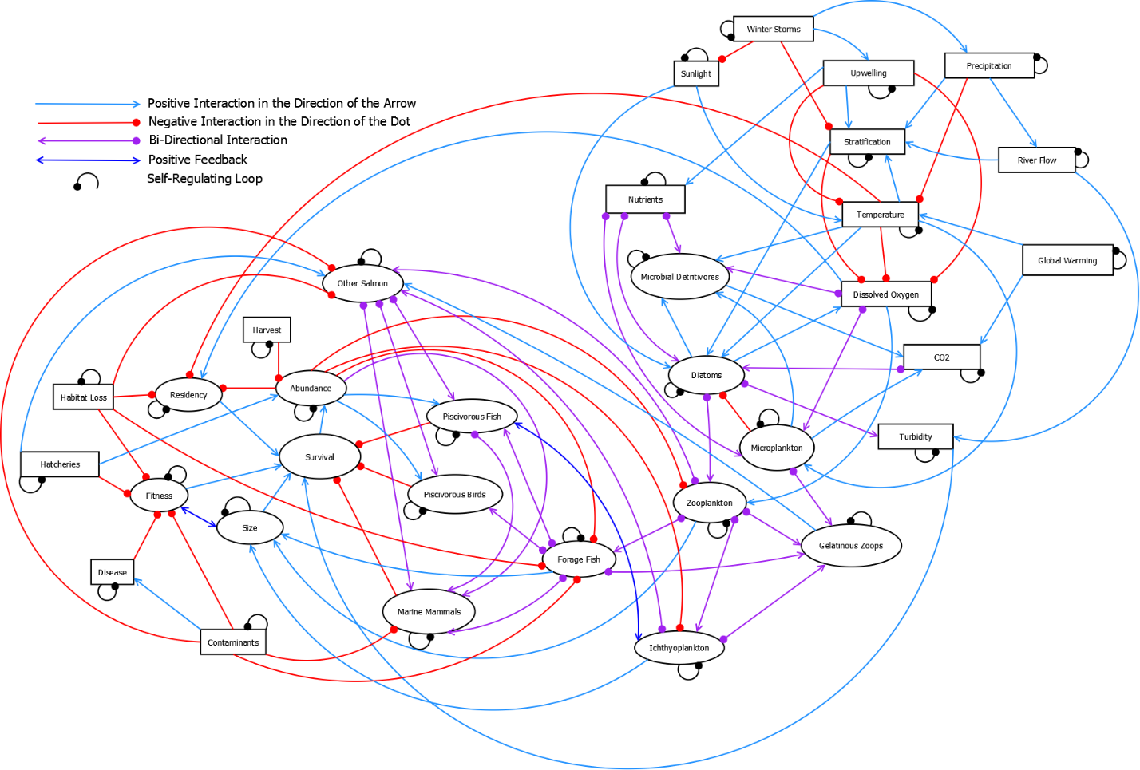

Figure 1. Conceptual directed diagram (digraph) of the Salish Sea in relation to survival of salmon. Model compartments (ovals or rectangles) represent biomass pools, ecosystem drivers, and traits on interest. Lines with arrows show positive relationships; lines with filled circles show negative relationships. Small negative loops on model compartments represent self-limiting functions.

THIS FIGURE SHOULD BE REDONE (Ideas: remove outlier or make broken y-axis so the others show up better, change colors so focal species are all cool colors and non-focal are all warm colors and vary symbols if needed for black and white, better axis labels)

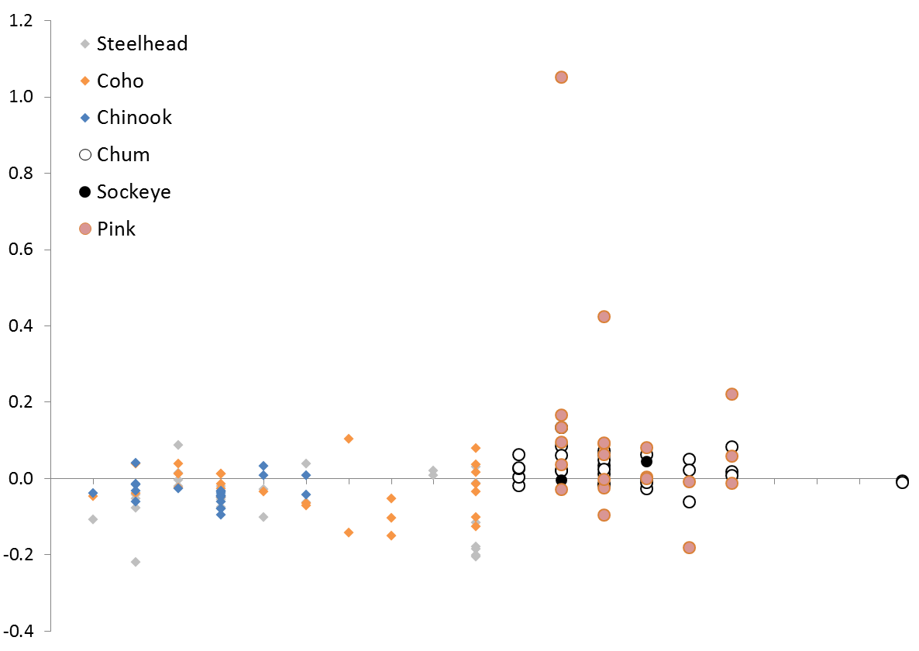

Puget Sound JDF

Strait of

Georgia

JS PC

Population Trend (Holmes 2001)

SS CB HC WB SG CG NS

SS CB HC WB SG CG NS

Puget Sound JDF

Strait of

Georgia

JS PC

Figure 2. Salmon Population trends within the Salish Sea.

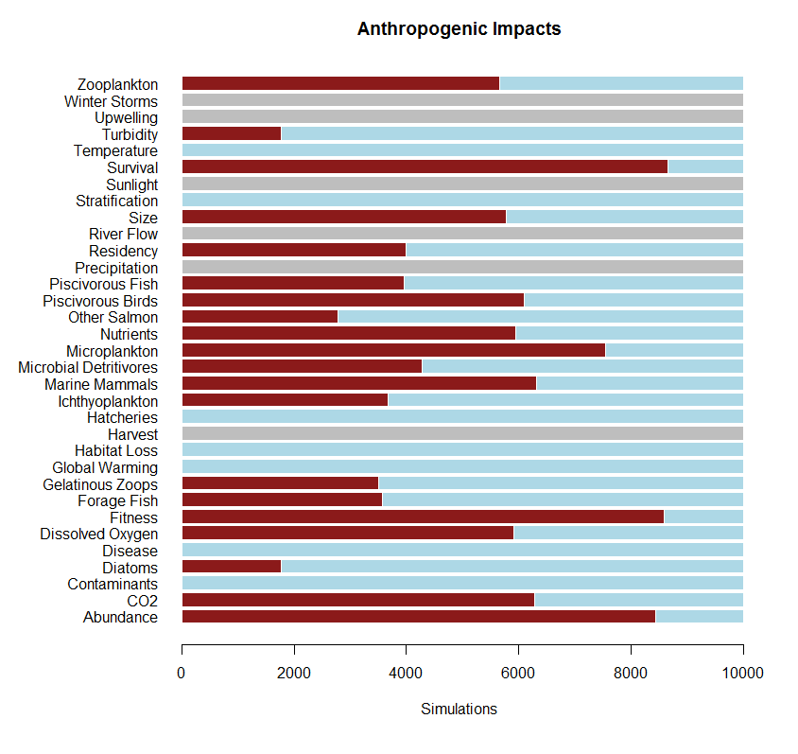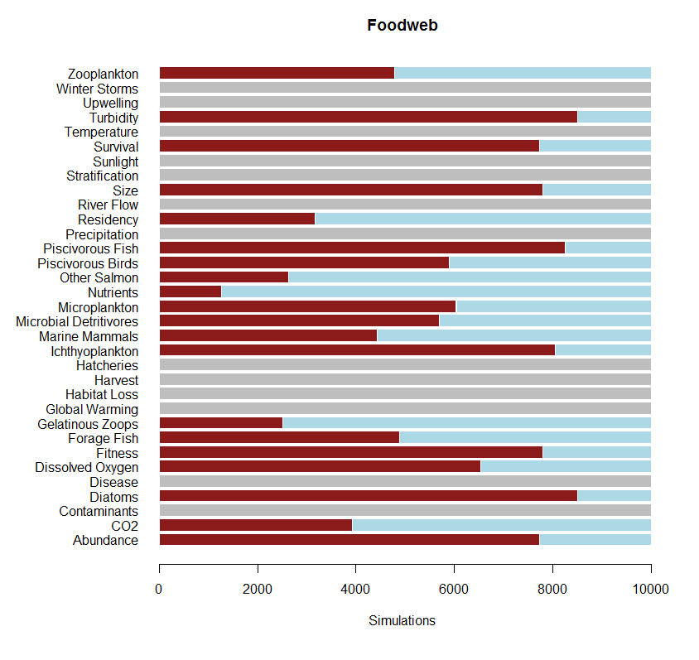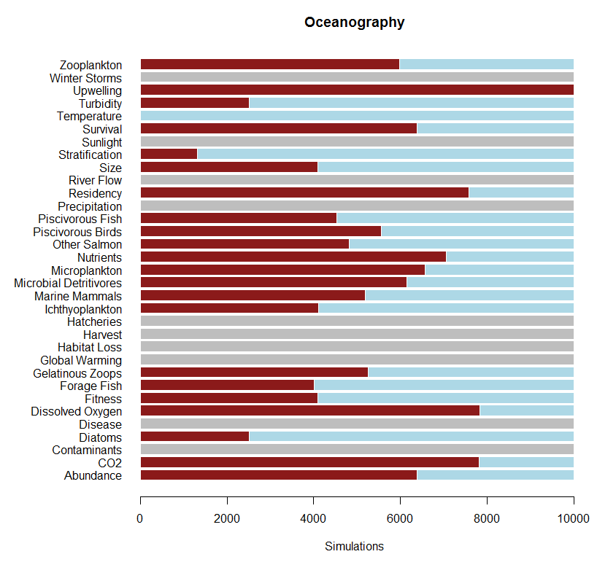

Figure 3. Responses from driver groups.

Appendix 1. Model Output for Individual Perturbations

Model output showing 6 model nodes of interest: Salmon Survival, Salmon Abundance, Salmon Size, Residency, Fitness and Other Salmon. Other Salmon refers to the populations (chum, pink, and sockeye) which have not seen a noticeable decline in survival in recent decades. In each plot box, the model node that was “pressed” is shown in the title, with the direction of the press (1=positive, -1=negative) shown below. The bar graphs indicate the proportion of model simulations with negative (red bars) and positive (blue bars) outcomes for that model node given the invoked press perturbation. Where the bars are dark gray, there was no impact to those nodes.

